Experiment #4 – Accelerator and Wrappers

Ava Mirmohammadmahdi 810199501
Nesa Abbasi 810199457

1. Exponential Engine
1.1
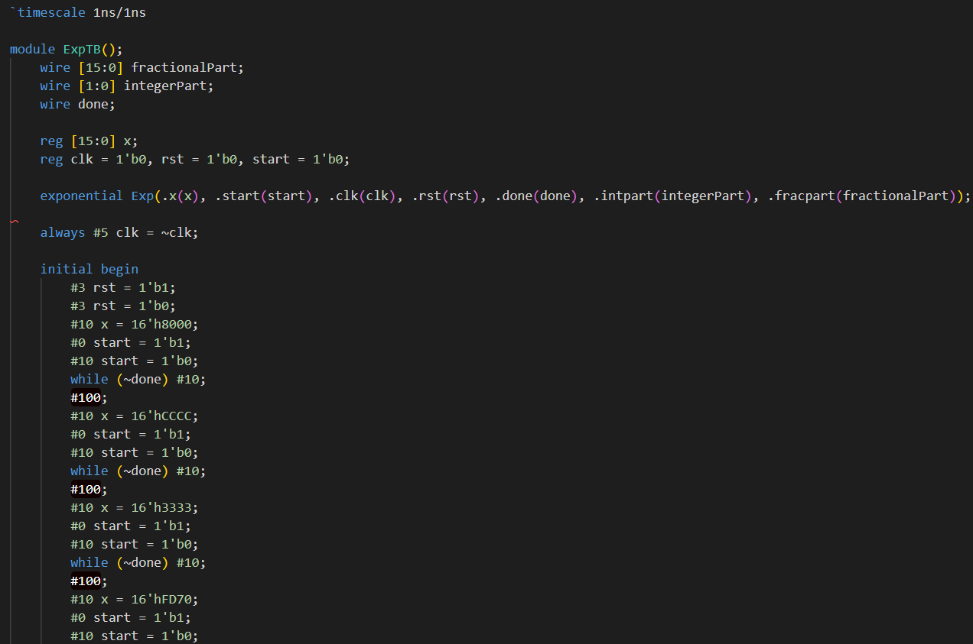
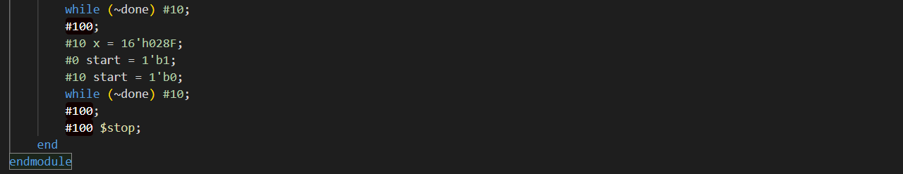
Fig. 1 Verilog Testbench

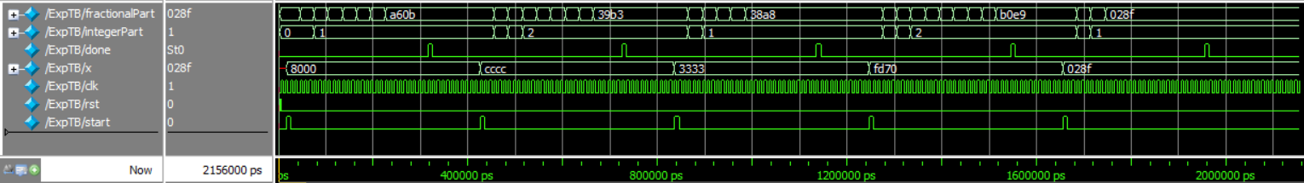
Fig. 2 Simulation

Input 0x8000 ➡️ 0x0A5E3
Input 0xCCC ➡️ 0x233F7
Input 0x3333 ➡️ 0x13581
Input 0xFD70 ➡️ 0x2B01E5
Input 0x028F ➡️ 0x10000
The difference is because of the exponential engine.

1.2
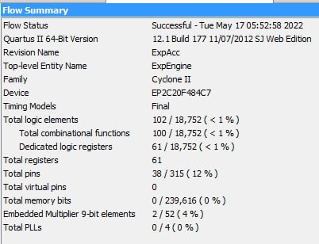
Fig. 3 Synthesis result
1.3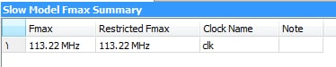
Fig. 4 Maximum frequency

2. The Wrapper Controller
2.1
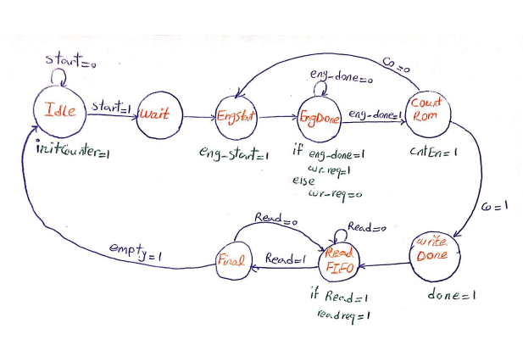
Fig. 5 State Diagram

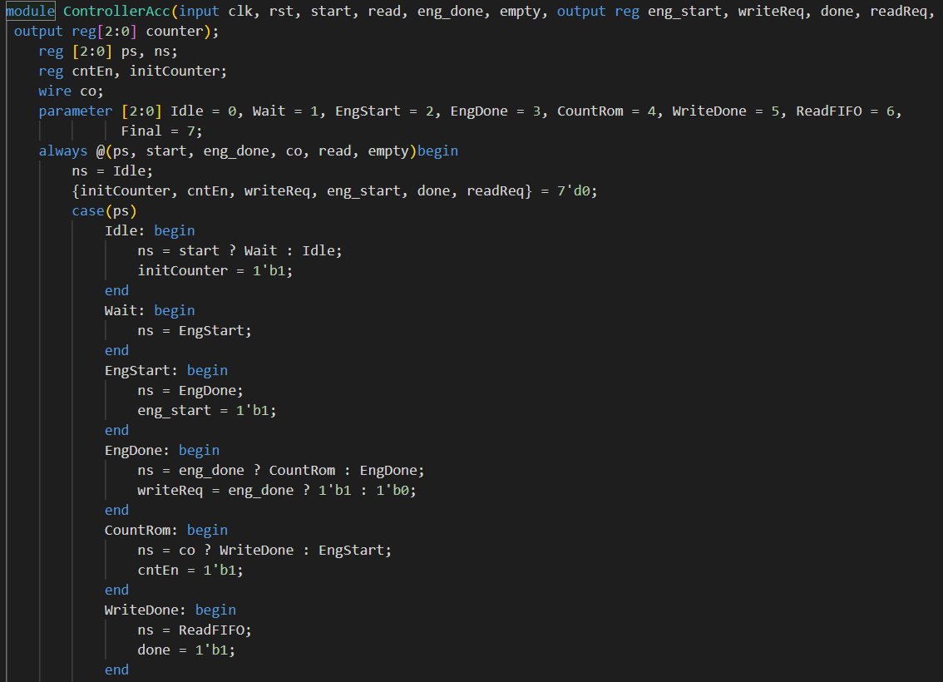
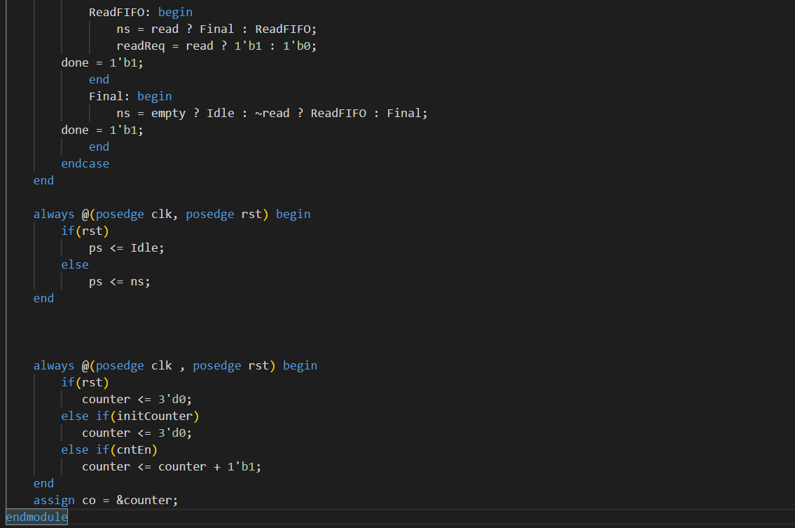
Fig. 6 Controller Verilog

2.2
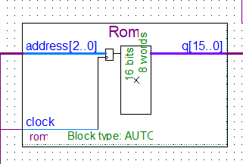
Fig. 7 Rom IP

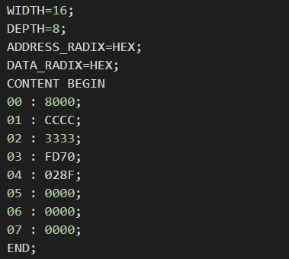
Fig. 8 Mif File

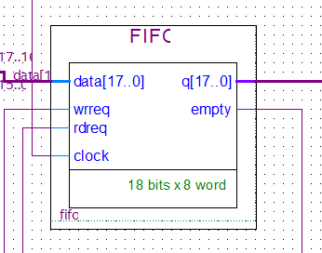
Fig. 9 FIFO IP

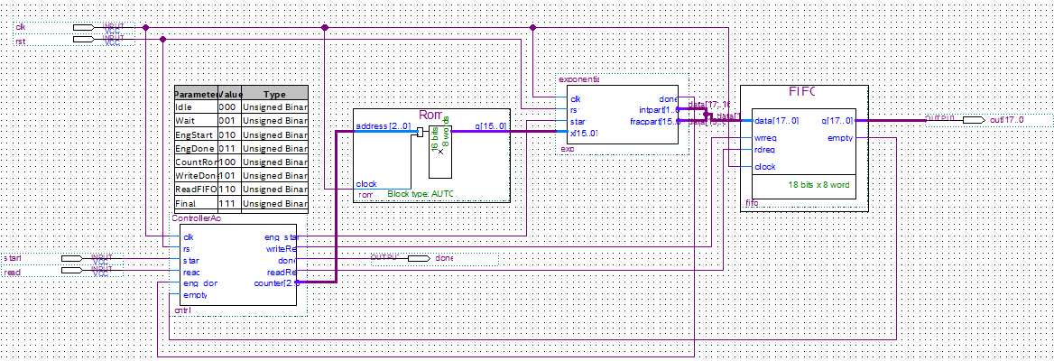
Fig. 10 The accelerator block diagram

2.4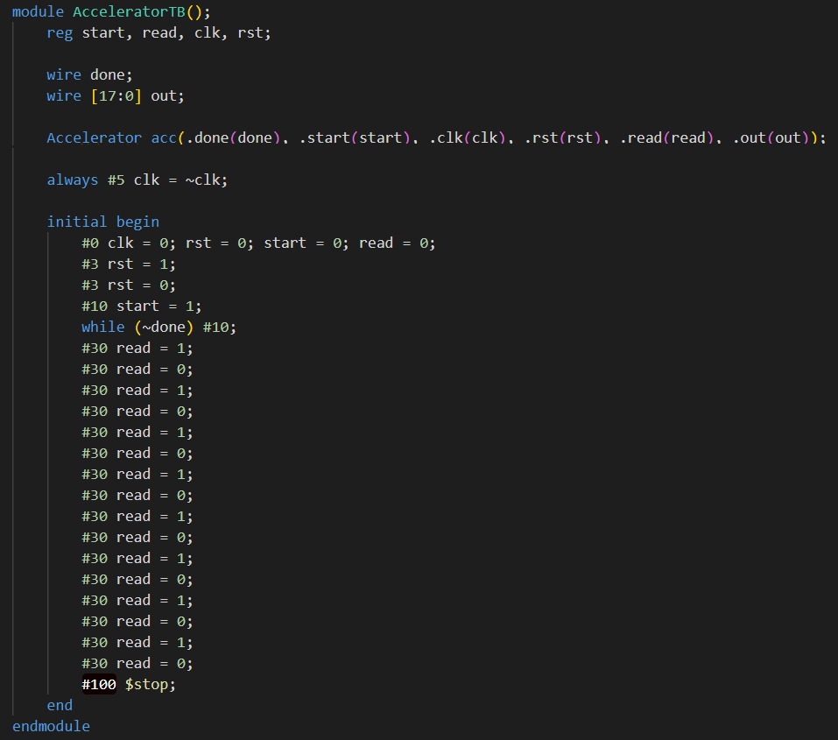
Fig. 11 Accelerator Testbench
2.5
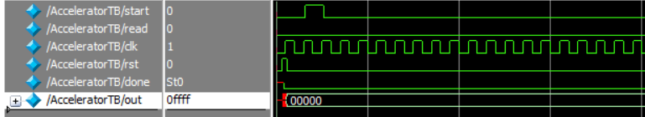
Fig. 12 Complete pulse on signal “start”
2.6
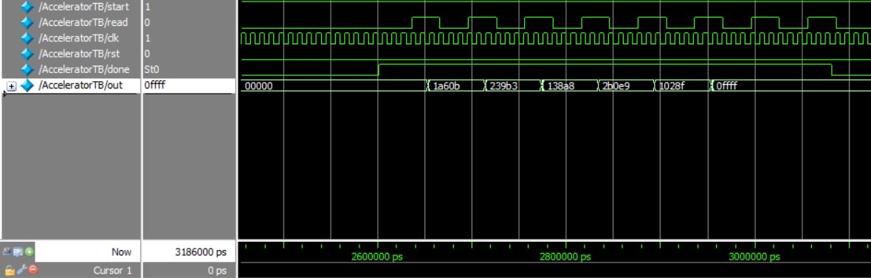
Fig. 13 Simulation result

3.Implementing Accelerator on FPGA
3.1
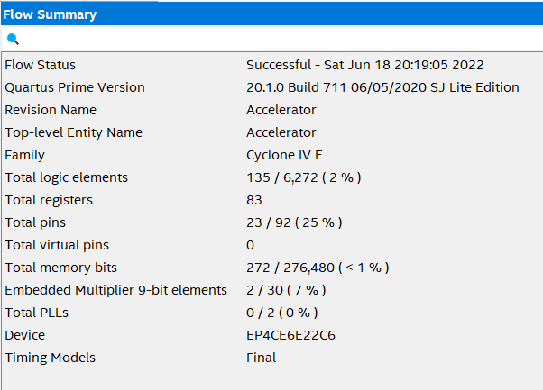
Fig. 14 Synthesis report

3.2
We connected Done signal to LED 9, Start pin to SW9 and Read to SW0. We read the results one by one by setting SW0 to one. After LED9 turned on.

3.3
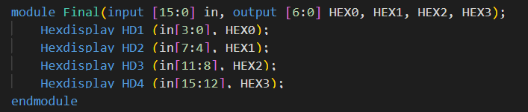
Fig. 15 Converter for 7 Segment display

To convert data for 7 segment display, we omitted 2 least significant bits.

3.4
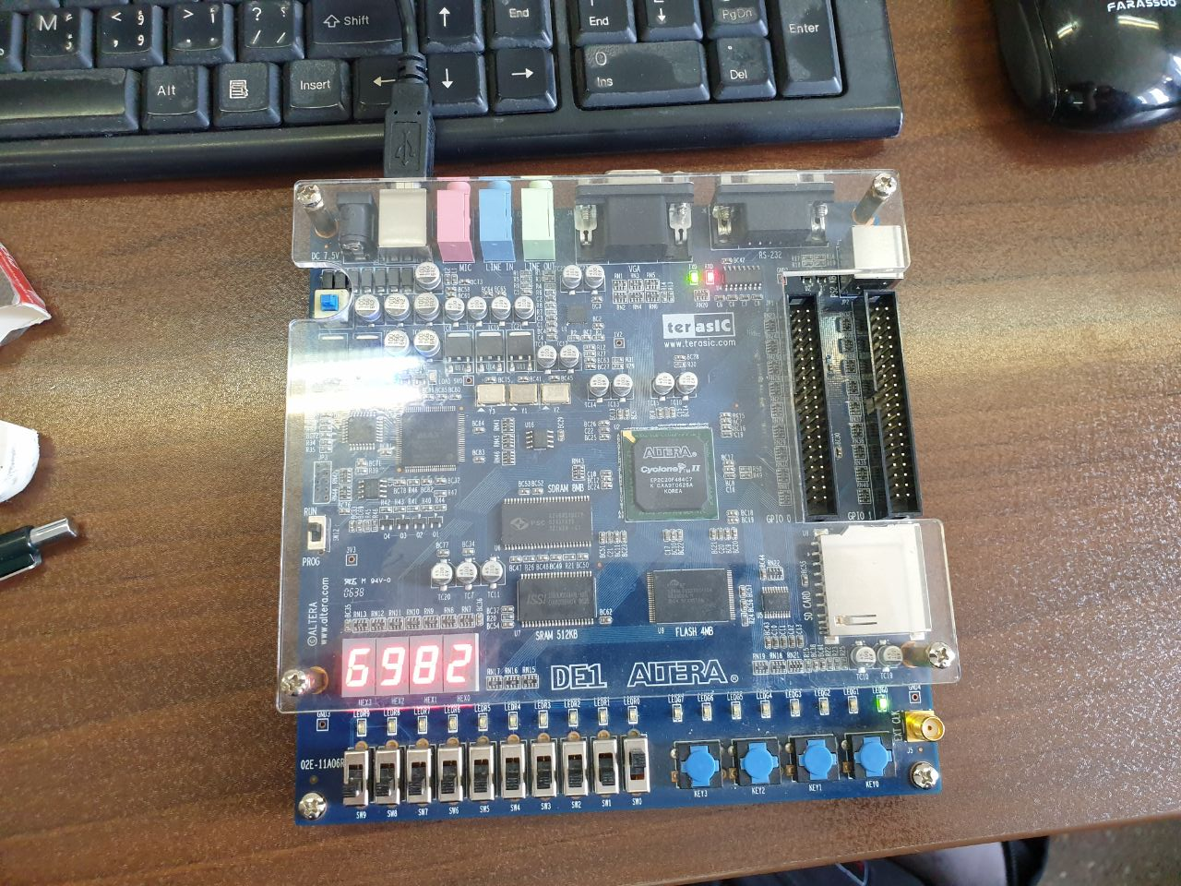
Fig. 16 First output
18 bits binary ➡️ Omit 2 least significant bits ➡️ Hex
011010011000001011 ➡️ 011010011000001011 ➡️ 6982
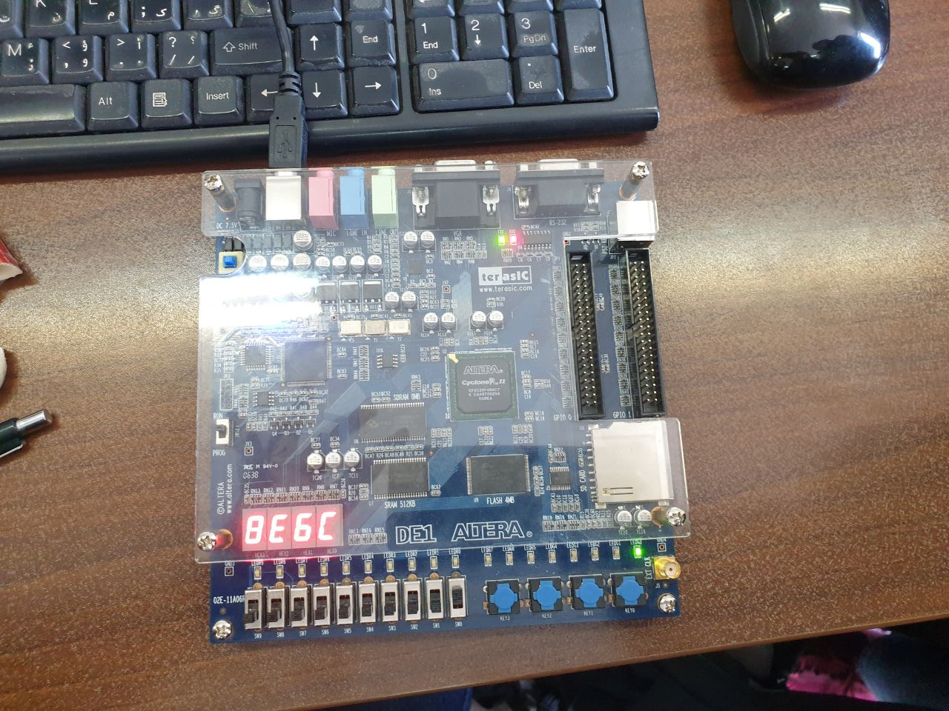
Fig. 17 Second output
18 bits binary ➡️ Omit 2 least significant bits ➡️ Hex
100011100110110011 ➡️ 100011100110110011➡️ 8E6C

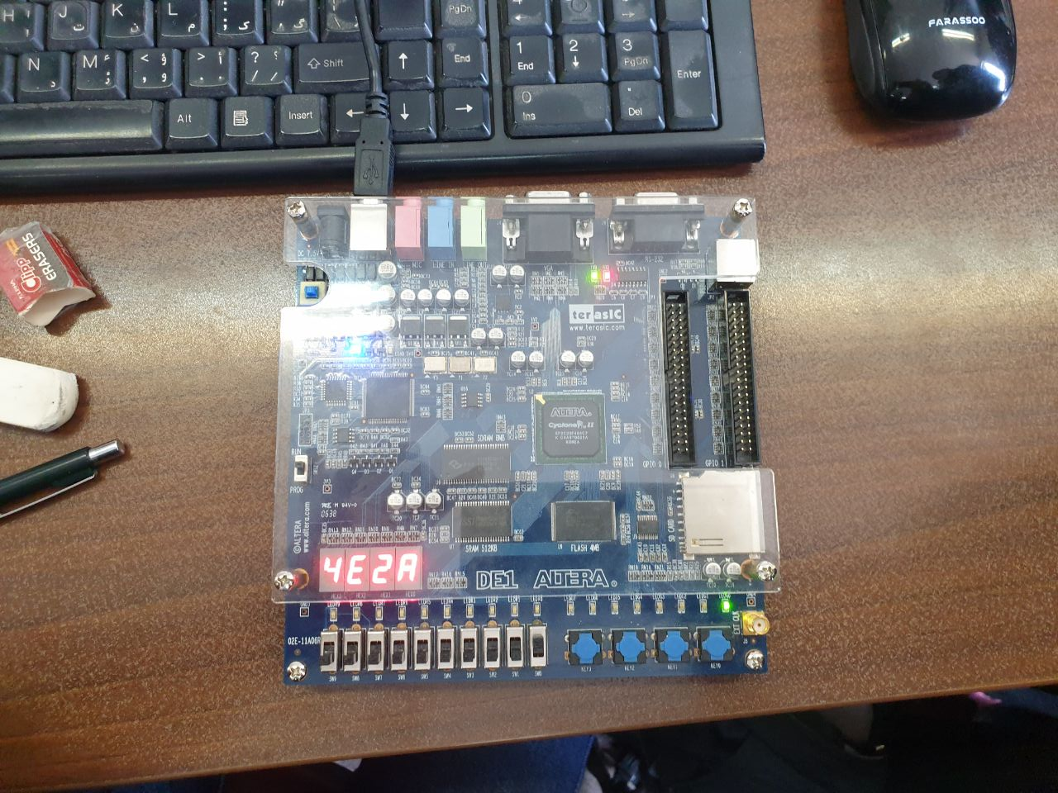
Fig. 18 Third output
18 bits binary ➡️ Omit 2 least significant bits ➡️ Hex
010011100010101000 ➡️ 010011100010101000 ➡️ 4E2A

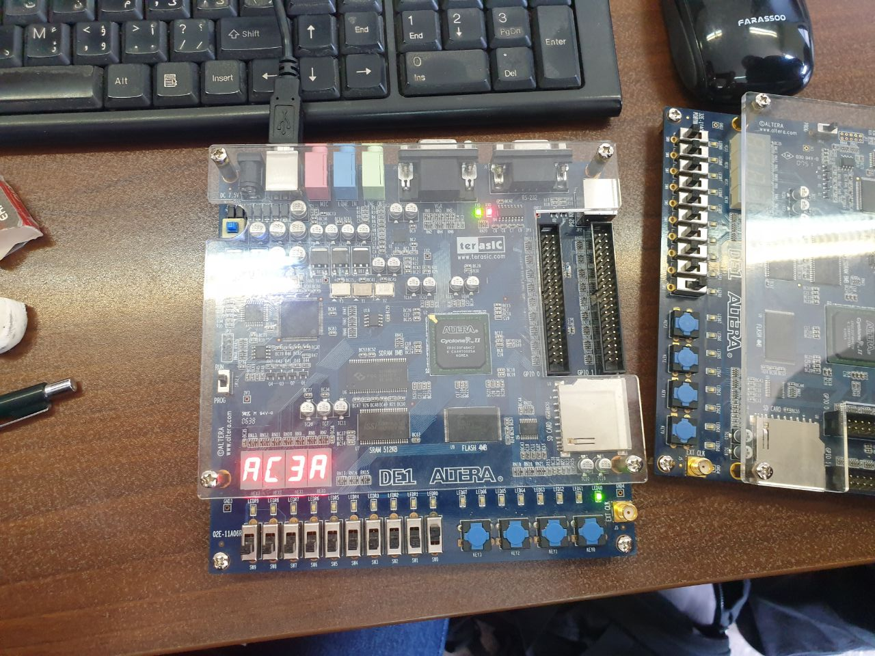
Fig. 19 Fourth output
18 bits binary ➡️ Omit 2 least significant bits ➡️ Hex
101011000011101001 ➡️ 101011000011101001 ➡️ AC3A
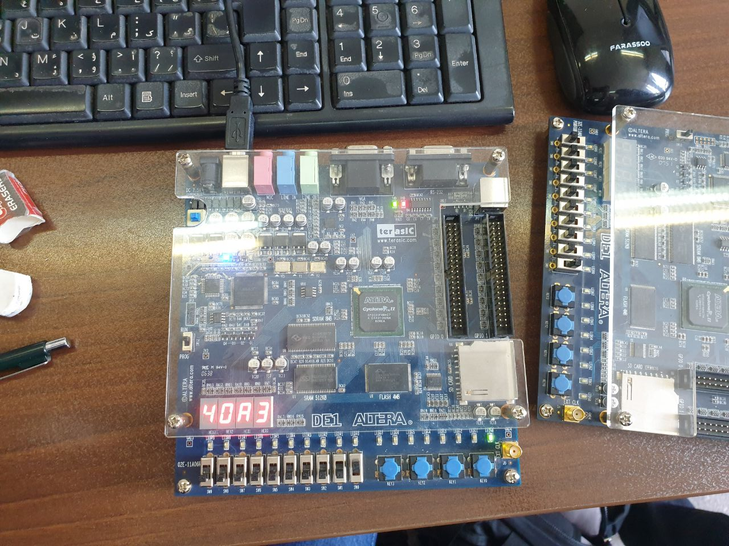
Fig. 20 Fifth output
18 bits binary ➡️ Omit 2 least significant bits ➡️ Hex
010000001010001111 ➡️ 010000001010001111 ➡️ 40A3

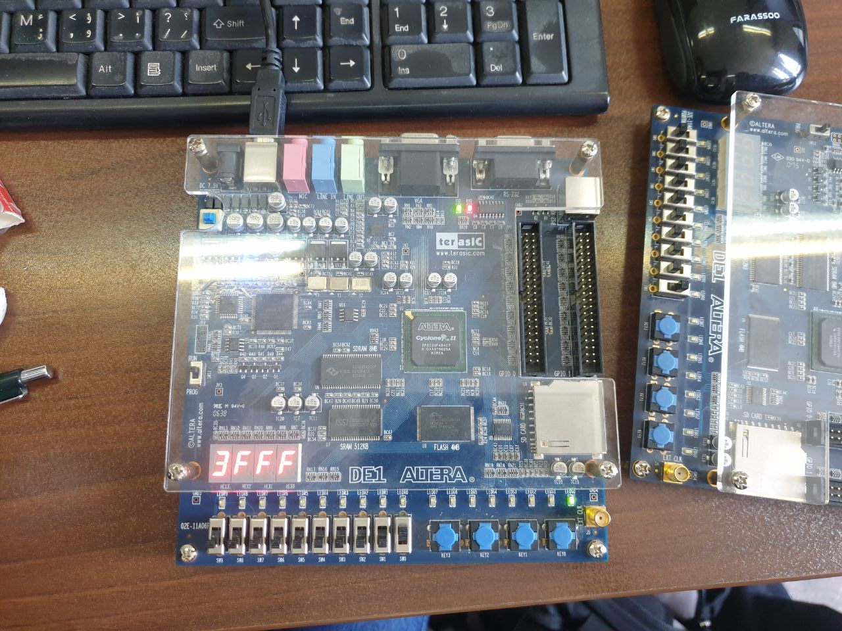
Fig. 21 Sixth output
18 bits binary ➡️ Omit 2 least significant bits ➡️ Hex
001111111111111111 ➡️ 001111111111111111 ➡️ 3FFF

If we convert our 18 bit input from hex to binary and ommit 2 least significant bits of it and then convert it to hex the output is the same as we ecpected.

